# **Time Series Forecasting**

## Introduction

Following the theme from task 1, I predicted the price of Anglo-American (AAL) shares and a similar company – BHP Group (BHP). The model I used is ARIMA, AutoRegressive Integrated Moving Average. ARIMA models use differencing to convert a non-stationary time series into a stationary one, and then predict future values from historical data.

## Content

**Python script:** 20210122_LF_Task2_Time_Series_Forecasting.py **Input:** yfinance stock data **Output:** See findings below

## Process

I first downloaded the stock price history from Yahoo Finance and stored the data as a pandas dataframe and checked the closing price plot (figure 1). Next, I checked the data for stationarity (figure 2). This is important because, in its absence, a model describing the data will vary in accuracy at different time points. In figure 2 we can see the rolling mean and standard deviation are decreasing, also the test statistic is greater than the critical values (figure 3) so our data is not stationary. We can achieve a stationary dataset by separating seasonality and trend.

I took the log of the series to reduce the trend and then found the rolling average, this is a statistic that captures the average change in a data series over time. (figure 4)

Now we split the data into a training and testing set and use AutoARIMA to provide the optimum parameters to use for the model (figure 5). These values are p,d, and q as 2,1 and 1 respectively. Finally, we run our model on the test data to compare the predictions with the actual results, the orange line shows the predicted stock price, and the dark blue line shows the actual stock price (figure 6). Around 1% MAPE(Mean Absolute Percentage Error) implies the model is about 99% accurate in predicting the test set observations. The model works well so we will use this to calculate the stock price in two weeks.

To predict the stock price in two weeks’ time I created an empty series with Dates for the next two weeks to test on and added this series to the previous test set. Although the results show the stock price is likely to remain around the same price as it is currently (figure 7), these are the log values of the predicted stock price. The log of the predicted price after 2 weeks is 7.88, this means price is expected to be 2660.97 in two weeks.

I repeated the above steps for BHP Group (BHP). You can use the same references to the figures as above. For BHP the rolling average and standard deviation are increasing, the AutoARIMA for the test data used the parameters 2,1 and 0 and the MAPE was around 2.8%. The two-week prediction used 1,1 and 0. The log of the predicted price of BHP is 4.26 so the predicted price is 70.94p,

## Findings

### **Anglo American**

Figure 1 - closing price plot

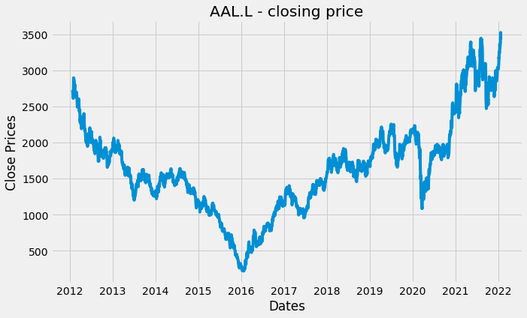

Figure 2 – Rolling Mean and Standard Deviation

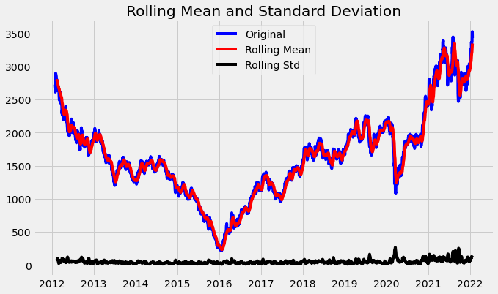

Figure 3 – Dickery fuller test

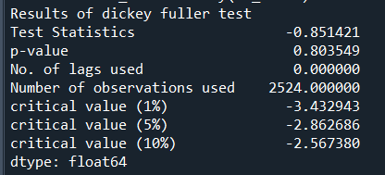

Figure 4 – stationary moving average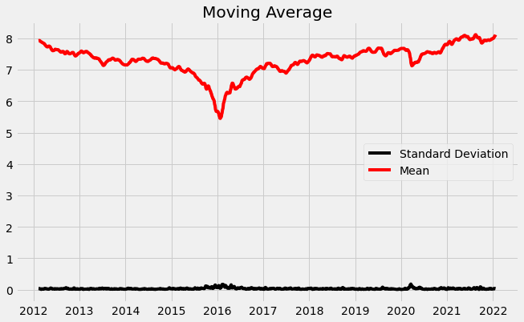

Figure 5 – AutoARIMA

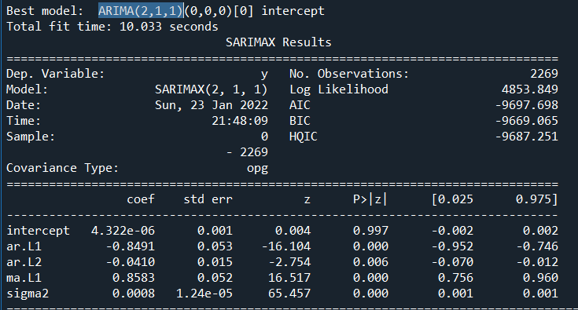

Figure 6 – Prediction on test data

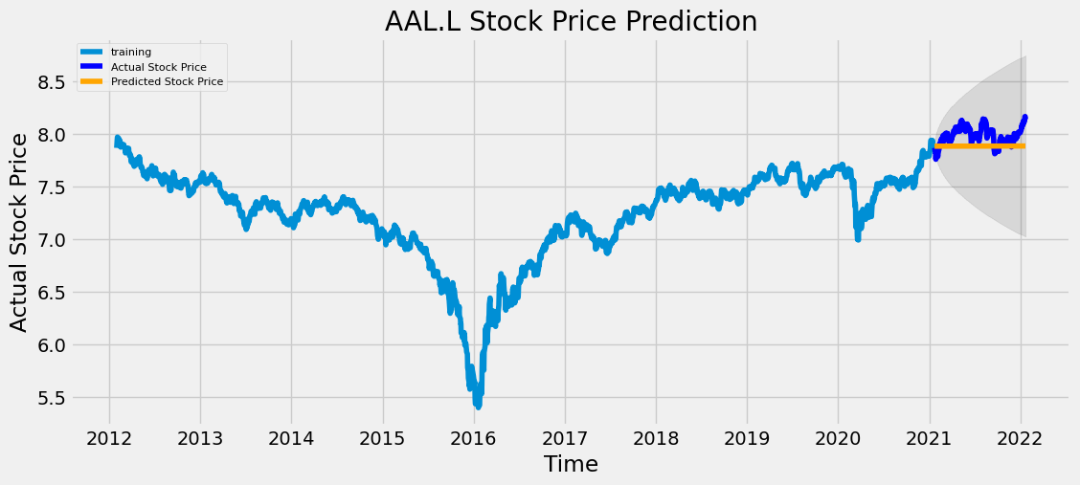

Figure 7 – Predicting price of stock in two weeks

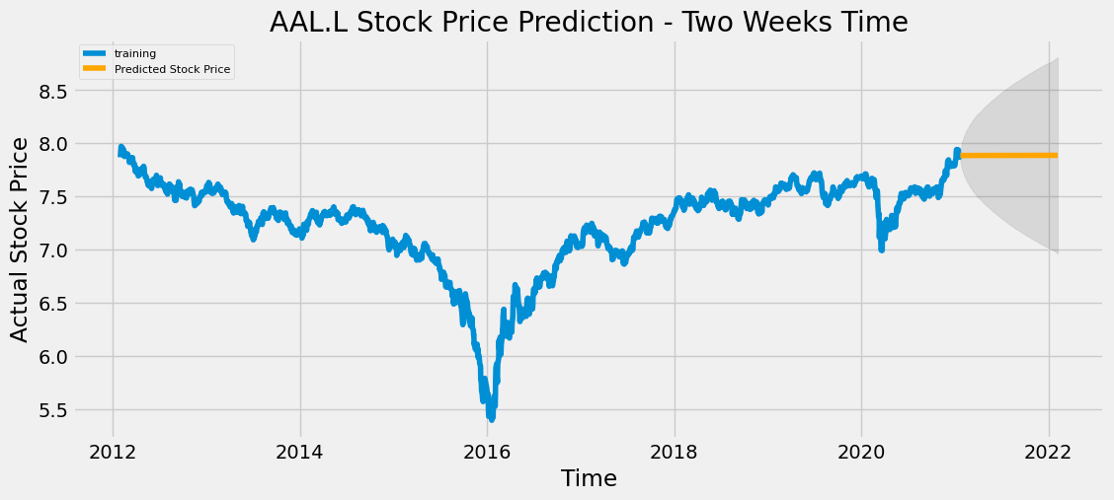

### **BHP Group**

Closing price plot

Figure 1 - closing price plot

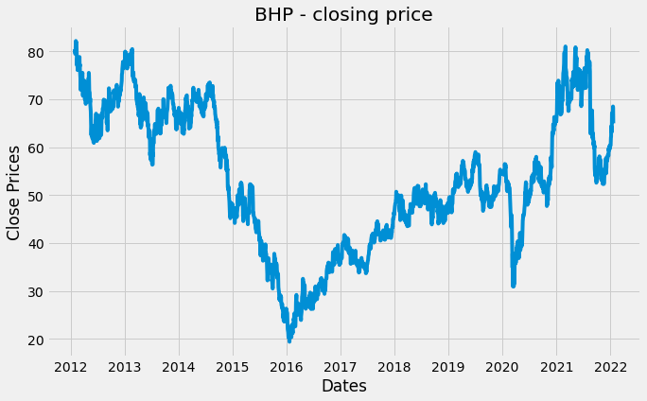

Figure 2 – Rolling Mean and Standard Deviation

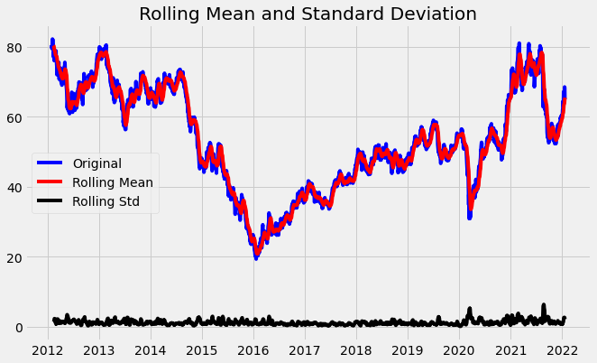

Figure 3 – Dickery fuller test

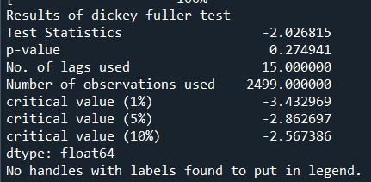

Figure 4 – stationary moving average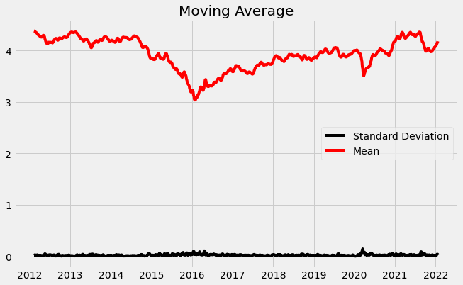

Figure 5 – AutoARIMA

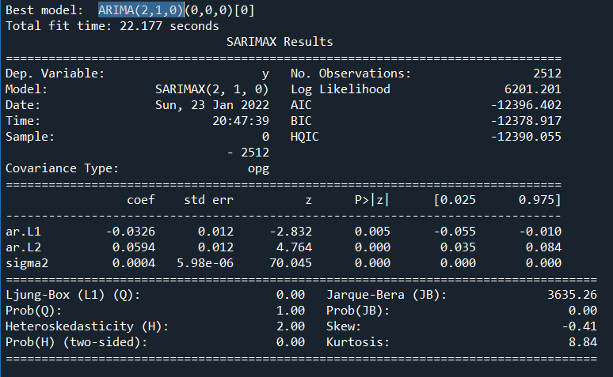

Figure 6 – Prediction on test data

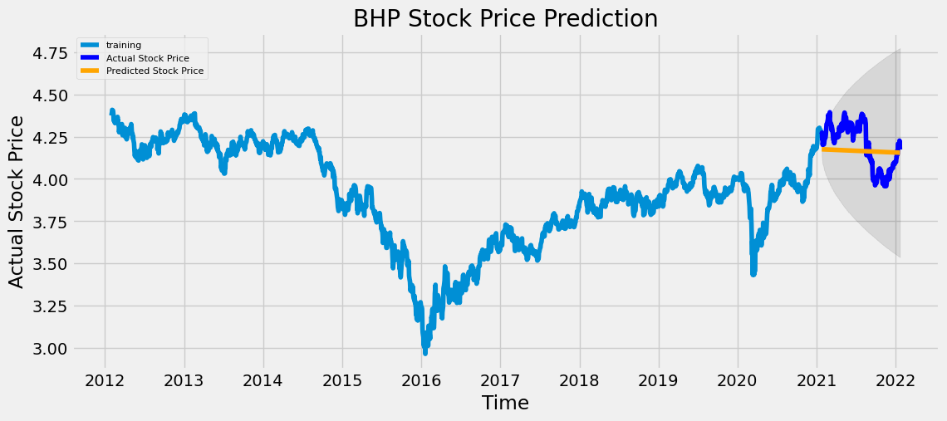

Figure 7 – Predicting price of stock in two weeks

